# Introduction to Level Design

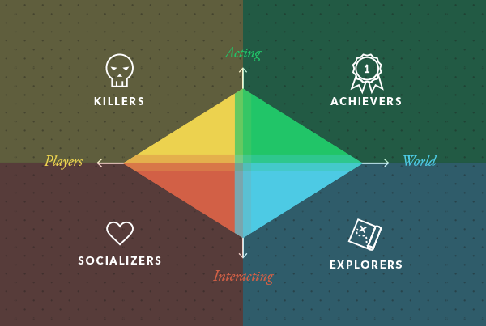Bartle’s taxonomy of player types -

* Killers – 10%
* Achievers – 10%
* Explorers – 10%
* Socializers – 70%
* Pacing is an important aspect of level design, it refers to the “rhythm” of a certain section of a game, especially as it relates to the player’s emotional state.
* Knowing where to place important moments or beats, and where and how often to place decision points for a player, is key to designing a good level.
* A moment is a unique situation that will evoke an emotional response or require the player to make a meaningful choice.
* A beat is generally a smaller moment, usually a split-second decision or a quick time event.
* Flow is the process of the player moving through the level fluidly and naturally. Depending on the genre of game, you may want to encourage or discourage certain kinds of flow.
* Gating is the process of forcing a player forward by preventing them from going backwards by, for example, locking the doors behind.
* Rule of Thirds – Important things are generally placed at the dividing lines, either horizontally or vertically.

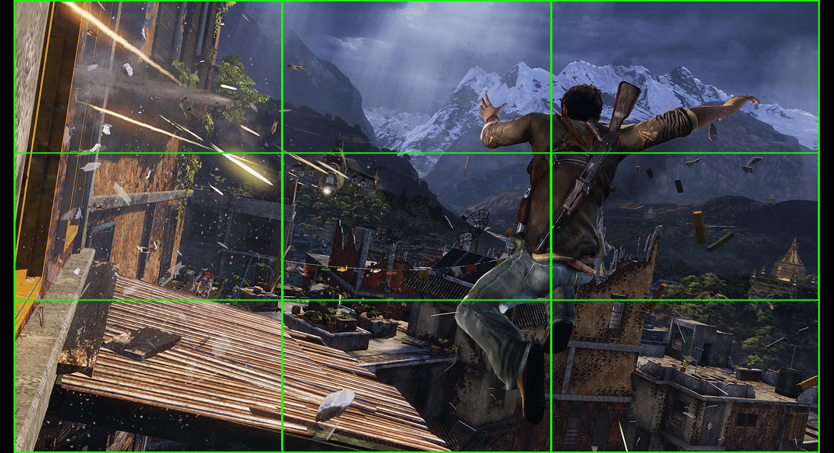

* Leading Lines – you can use existing lines in the environment to lead the player’s gaze.

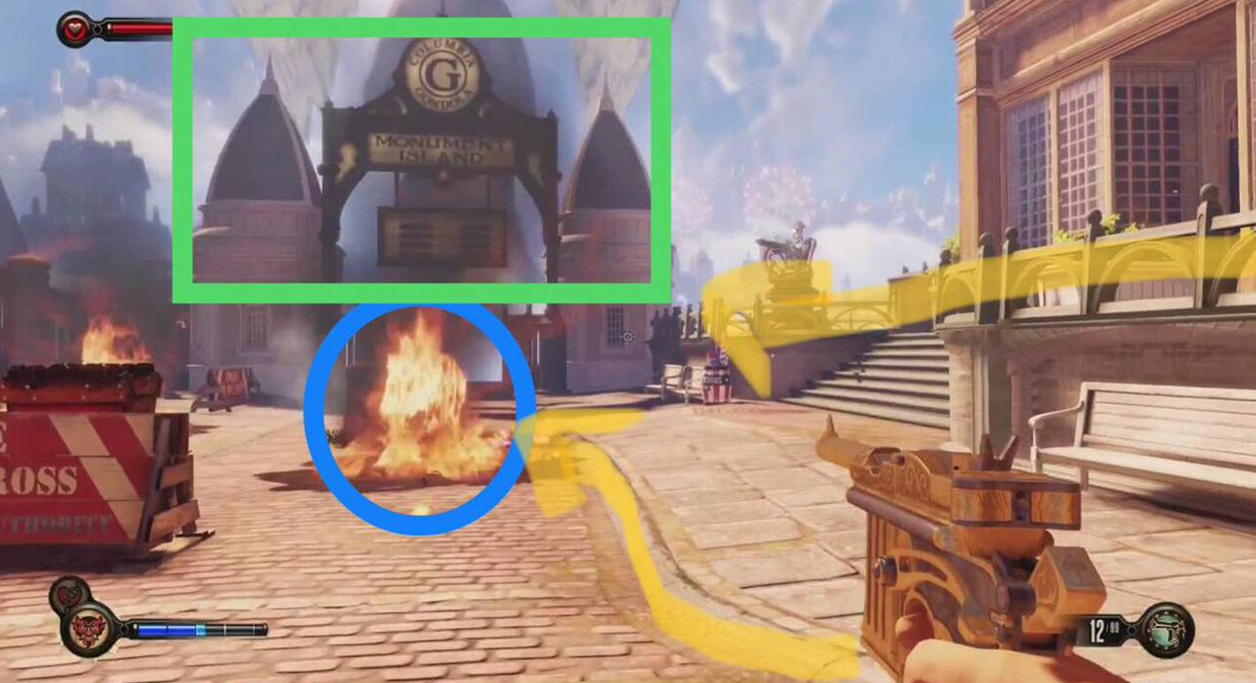

* Landmarks – also called points of interest are large, recognizable set pieces in the game environment which can also be helpful in orientation.
* Sight lines – literally how far, in what direction, and to what extent a player can see (FOV). Providing variation in sight lines is critical in creating varied combat encounters.
* Level Design – Planning stage – Concept, layout and mood

- Paper prototype stage – general idea of how spaces connect, type of experience and the flow of level.

- Grey block stage – physical structure of the level in the form of crude 3D models.

- Detailing

* Guidance – the use of non-verbal game elements to guide players in an intended direction.
* Safe Zone – areas in the current scene where the players are not exposed to negative interactions.
* Foreshadowing – a literary concept where the author hints at something that will happen later in the story.
* Branching – providing players with multiple paths to reach their objective.
* Pace Breaking – purposely changing the dramatic arc of the game from one scene to the next.
* Good level design is fun to navigate.
* Good level design doesn’t rely on words to tell the story.
* Good level design tells the player what to do, but not how to do it.
* Good level design constantly teaches the player something new.
* Good level design is full of surprises.
* The interest curve is a visual model of the player’s level of excitement as they play a game and is designed to achieve a flow state in the player by keeping them at a consistently high level of engagement.

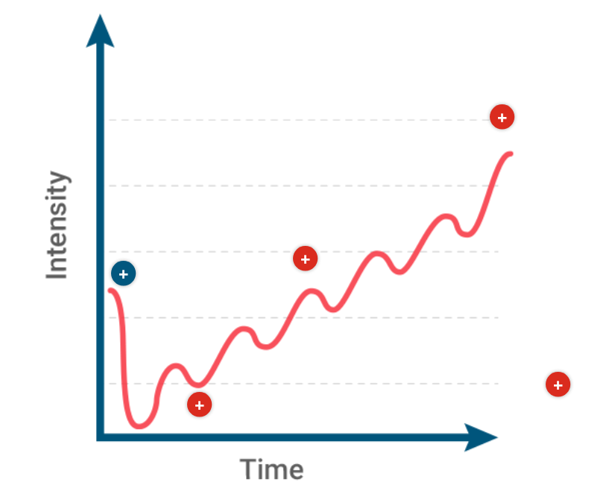

* Starting off with high intensity and drama serves to excite and engage the player immediately.